POWER BI PROJECT- “ADIDAS SALES ANALYSIS”

STEP 1: Load the data into Power BI, Import Excel workbook for desktop.

Select and Load The Data for use.

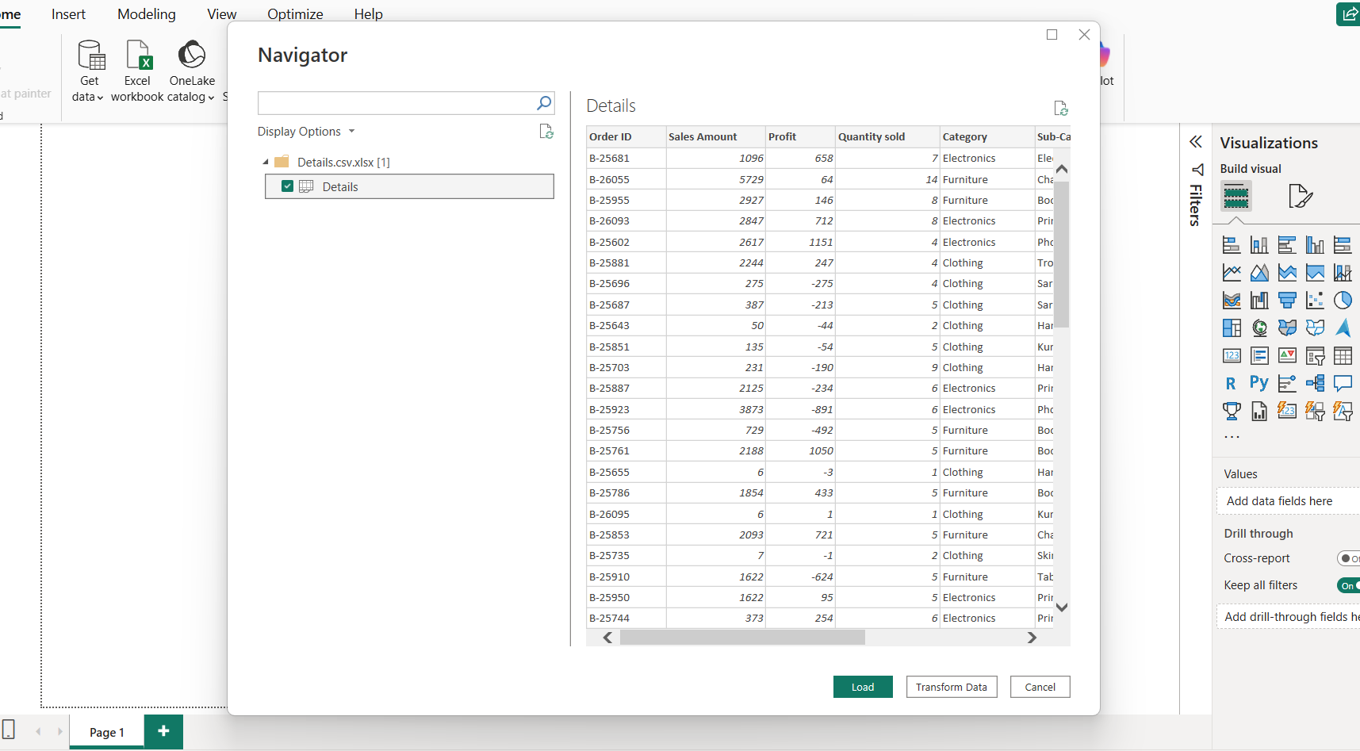

STEP2: Table View of the Data.

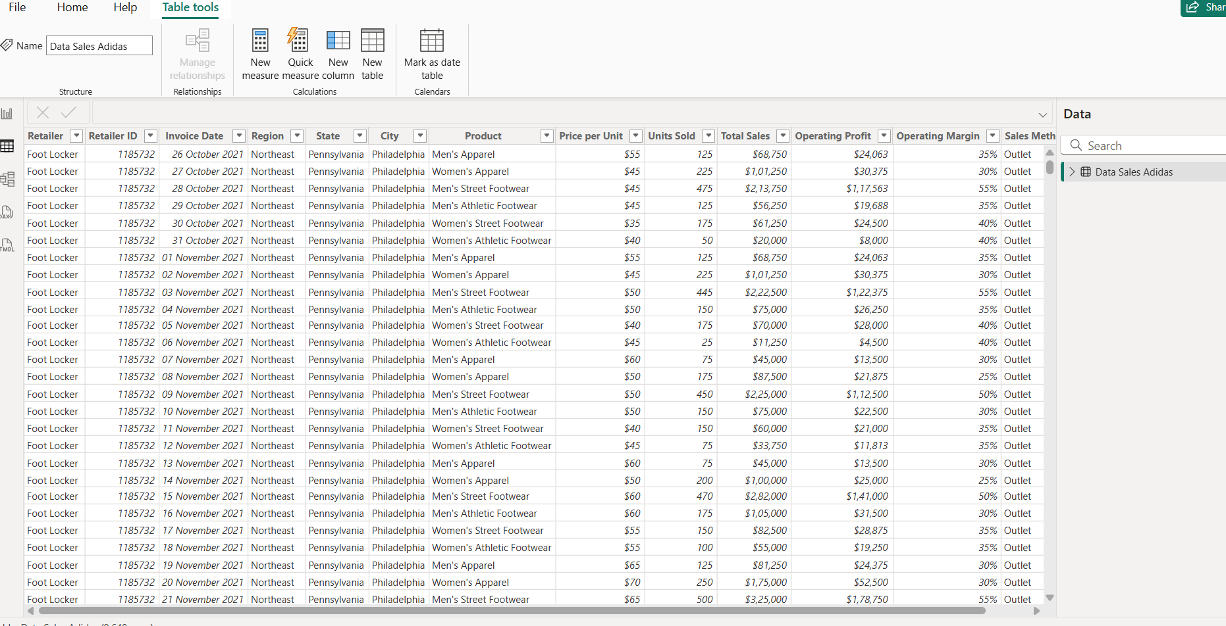

STEP 3: Cleaning of the data by removing duplicates, changing datatype and finding the missing data.

Transform Data is used to make changes.

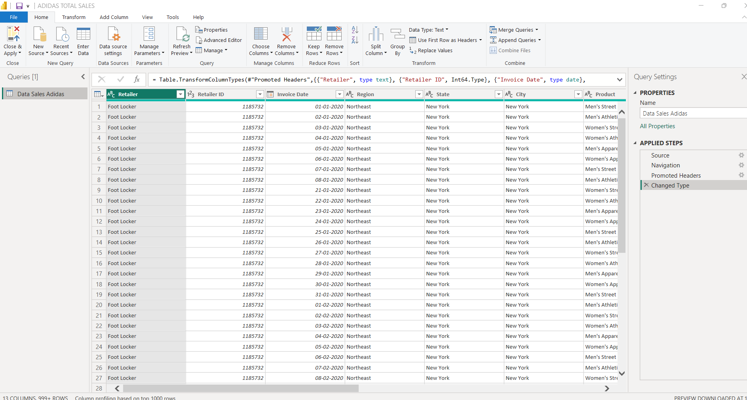

STEP 4:

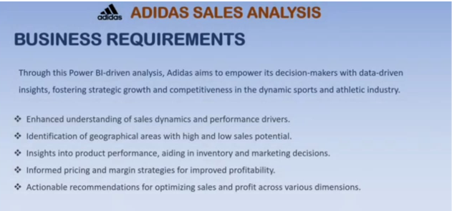

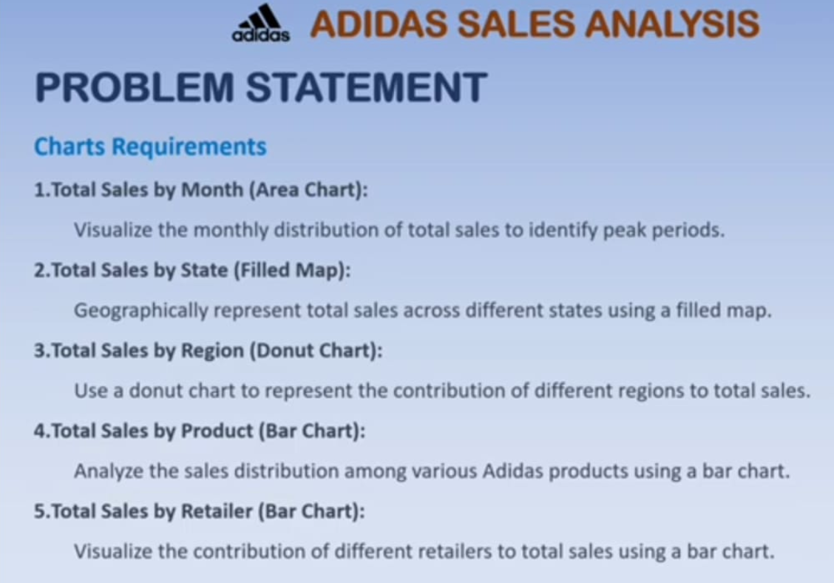

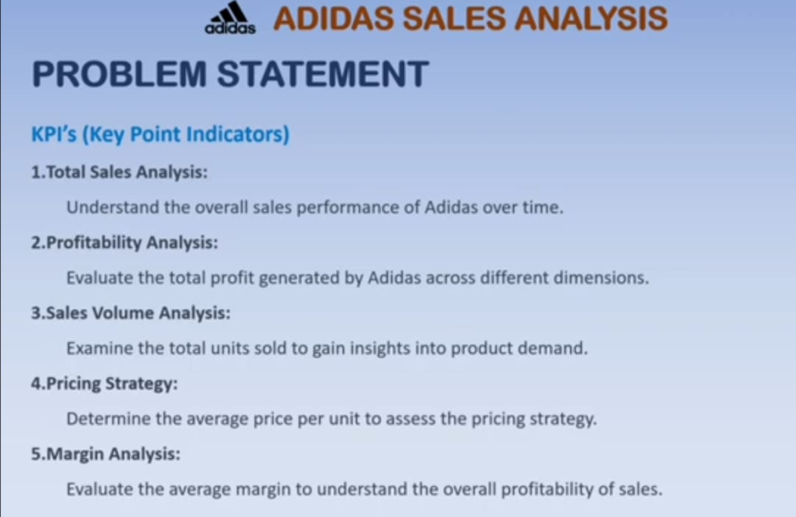

STEP 5: Total Sales, Operating Profit, Total units sold, Average Price per unit, Average Margin.

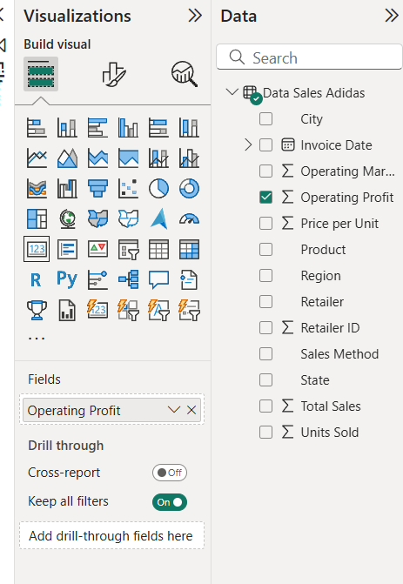

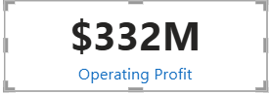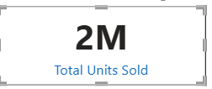

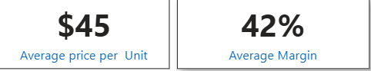

STEP 6: Total sales by month

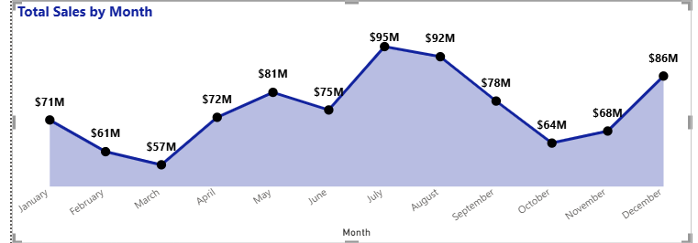

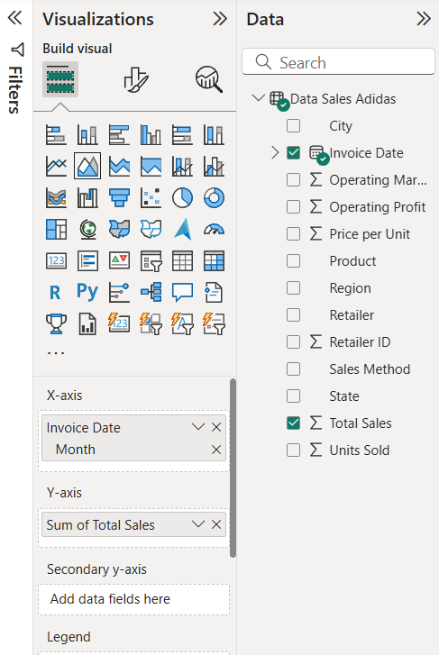

STEP 7: Total sales and units sold by state projection using map

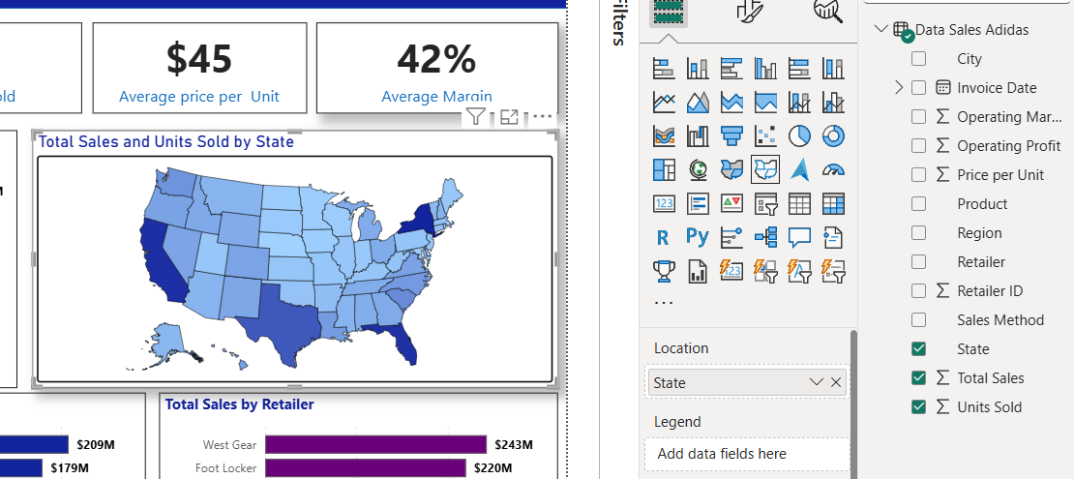

STEP 8: Doughnut chart Total sales by Region.

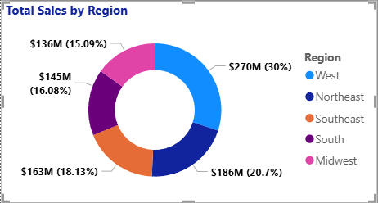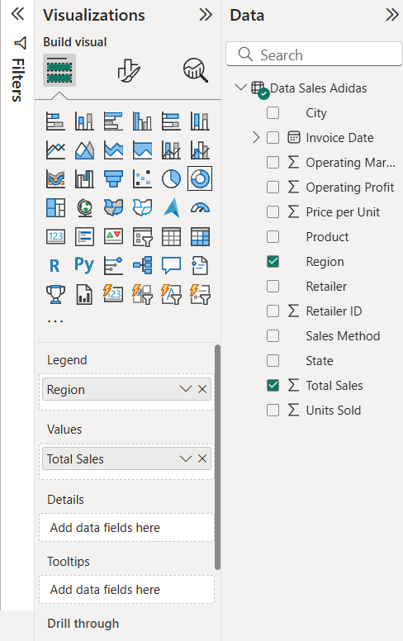

STEP 9: Total sales by product bar chart.

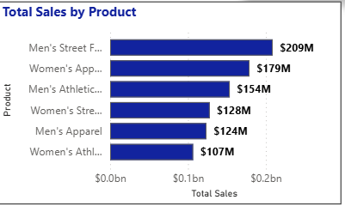

STEP 10: Total sales by Retailer.

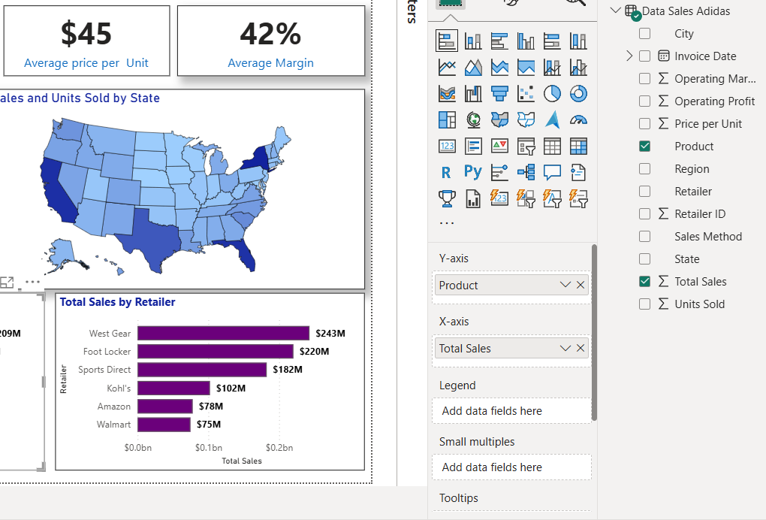

STEP 11: Creating Slicers for Region and Invoice Date.

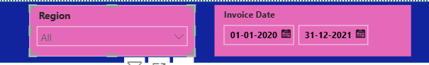

STEP 12: ADIDAS SALES ANALYSIS DASHBOARD.

